[RcppDynProg](https://github.com/WinVector/RcppDynProg" \t "_blank) is a new [Rcpp](https://cran.r-project.org/package=Rcpp) based [R](https://www.r-project.org/) package that implements simple, but powerful, table-based [dynamic programming](https://en.wikipedia.org/wiki/Dynamic_programming). This package can be used to optimally solve the minimum cost partition into intervals problem (described below) and is useful in building piecewise estimates of functions (shown in this note).

**The abstract problem**

The primary problem [RcppDynProg::solve\_dynamic\_program()](https://winvector.github.io/RcppDynProg/reference/solve_dynamic_program.html) is designed to solve is formally given as follows.

Minimum cost partition into intervals.

Given: a positive integer n and an a *n* by n matrix called costs.

Find: an increasing sequence of integers soln with length(soln)==k (>=2), soln[1] == 1, and soln[k] == n+1 such that sum[i=1,...,k-1] costs[soln[i], soln[i+1]-1] is minimized.

To rephrase: costs[i,j] is specifying the cost of taking the interval of integers {i,...,j} (inclusive) as a single element of our solution. The problem is to find the minimum cost [partition](https://en.wikipedia.org/wiki/Partition_of_a_set) of the set of integers {1,...,n} as a sequence of intervals. A user supplies a matrix of costs of *every* possible interval of integers, and the solver then finds what disjoint *set* of intervals that cover {1,...,n} have the lowest sum of costs. The user encodes their optimization problem a family of interval costs (n(n-1)/2 of them, which is a lot- but is tractable) and the algorithm quickly finds the best simultaneous set of intervals (there are 2^(n-1) partitions into intervals, so exhaustive search would not be practical).

We can illustrate this abstract problem as follows (if this is too abstract, please skip forward to the concrete application).

Suppose we have the following cost matrix.

costs <- matrix(c(1.5, NA ,NA ,1 ,0 , NA, 5, -1, 1),

nrow = 3)

print(costs)

# [,1] [,2] [,3]

# [1,] 1.5 1 5

# [2,] NA 0 -1

# [3,] NA NA 1

Then the optimal partition is found as follows.

library("RcppDynProg")

soln <- solve\_dynamic\_program(costs, nrow(costs))

print(soln)

# [1] 1 2 4

The sequence [1, 2, 4] is a just compact representation for the following sequence of intervals.

lapply(

seq\_len(length(soln)-1),

function(i) {

soln[i]:(soln[i+1]-1)

})

# [[1]]

# [1] 1

#

# [[2]]

# [1] 2 3

Which is saying the optimal partition into intervals is to the sequence of sets [{1}, {2, 3}] which has total cost costs[1,1] + costs[2,3]. The dynamic programming solver knew to take the expensive set {1} to allow the cheap set {2, 3} to be in its chosen partition. This is the essence of dynamic programming: finding an optimal *global* solution, even if it requires odd-looking local choices.

**An application**

The intended application of RcppDynProg is to find optimal piecewise solutions to single-variable modeling problems. For example consider the following data.

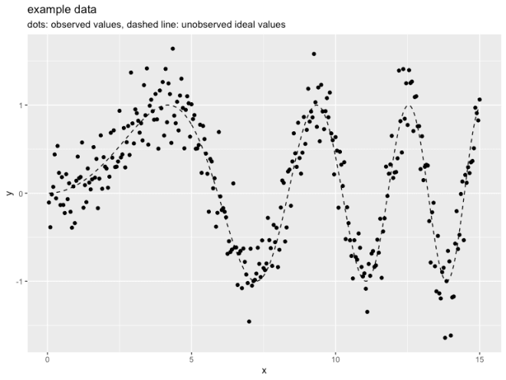

In the above we have an input (or independent variable) x and an observed outcome (or dependent variable) y\_observed (portrayed as points). y\_observed is the unobserved idea value y\_ideal (portrayed by the dashed curve) plus independent noise. The modeling goal is to get close the y\_ideal curve using the y\_observed observations. Obviously this [can be done with a smoothing spline](https://github.com/WinVector/RcppDynProg/blob/master/extras/SegmentationL.md), but let’s use RcppDynProg to find a piecewise linear fit.

To encode this as a dynamic programming problem we need to build a cost matrix that for every consecutive interval of x-values we have estimated the out-of sample quality of fit. This is supplied by the function RcppDynProg::lin\_costs() (using the [PRESS statistic](http://www.win-vector.com/blog/2014/09/estimating-generalization-error-with-the-press-statistic/)), but lets take a quick look at the idea.

The following interval is a good interval, as all the chosen points (shown in dark blue) are in a nearly linear arrangement. The in-sample price of the interval would be the total sum of residuals of a linear model fit on the selected region (and the out of sample price would be given by the PRESS statistic).

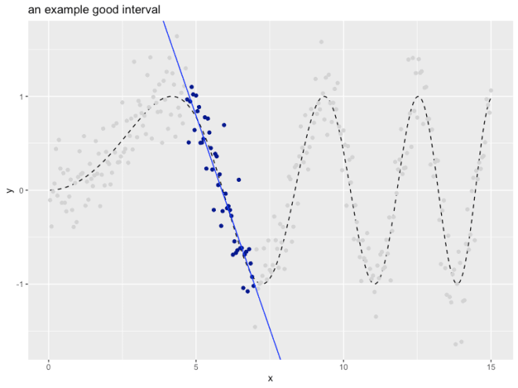

The "cost" (or loss) of this interval can be estimated as shown.

print(good\_interval\_indexes) # interval

# [1] 94 139

print(1 + good\_interval\_indexes[2] - good\_interval\_indexes[1]) # width

# [1] 46

fit <- lm(y\_observed ~ x,

data = d[good\_interval\_indexes[1]:good\_interval\_indexes[2], ])

sum(fit$residuals^2) # cost for interval

# [1] 2.807998

The following interval is a bad interval, as all the chosen points (shown in dark blue) are not in a nearly linear arrangement.

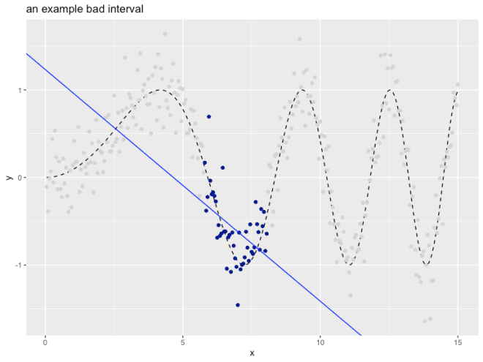

print(bad\_interval\_indexes) # interval

# [1] 116 161

print(1 + bad\_interval\_indexes[2] - bad\_interval\_indexes[1]) # width

# [1] 46

fit <- lm(y\_observed ~ x,

data = d[bad\_interval\_indexes[1]:bad\_interval\_indexes[2], ])

sum(fit$residuals^2) # cost for interval

# [1] 5.242647

The user would price all of the intervals individually, and then ask the solver to find the best simultaneous set of intervals.

The complete solution is worked as follows (using the [RcppDynProg::solve\_for\_partition()](https://winvector.github.io/RcppDynProg/reference/solve_for_partition.html) function which wraps all the steps together, converting from indices to x-coordinates).

x\_cuts <- solve\_for\_partition(d$x, d$y\_observed, penalty = 1)

print(x\_cuts)

# x pred group what

# 1 0.05 -0.1570880 1 left

# 2 4.65 1.1593754 1 right

# 3 4.70 1.0653666 2 left

# 4 6.95 -0.9770792 2 right

# 5 7.00 -1.2254925 3 left

# 6 9.20 0.8971391 3 right

# 7 9.25 1.3792437 4 left

# 8 11.10 -1.1542021 4 right

# 9 11.15 -1.0418353 5 left

# 10 12.50 1.1519490 5 right

# 11 12.55 1.3964906 6 left

# 12 13.75 -1.2045219 6 right

# 13 13.80 -1.3791405 7 left

# 14 15.00 1.0195679 7 right

d$estimate <- approx(x\_cuts$x, x\_cuts$pred,

xout = d$x,

method = "linear", rule = 2)$y

d$group <- as.character(

findInterval(d$x, x\_cuts[x\_cuts$what=="left", "x"]))

plt2 <- ggplot(data= d, aes(x = x)) +

geom\_line(aes(y = y\_ideal), linetype=2) +

geom\_point(aes(y = y\_observed, color = group)) +

geom\_line(aes(y = estimate, color = group)) +

ylab("y") +

ggtitle("RcppDynProg piecewise linear estimate",

subtitle = "dots: observed values, segments: observed group means, dashed line: unobserved true values") +

theme(legend.position = "none") +

scale\_color\_brewer(palette = "Dark2")

print(plt2)

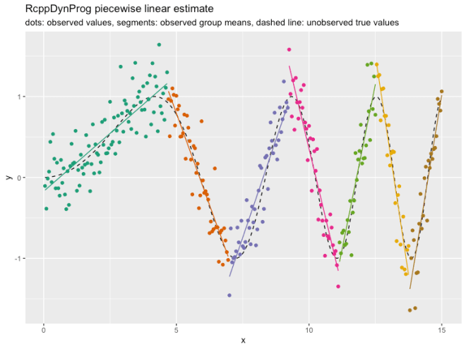

[RcppDynProg::solve\_for\_partition()](https://winvector.github.io/RcppDynProg/reference/solve_for_partition.html) finds a partition of a relation into a number of linear estimates. Each interval is priced using out-of sample cost via the [PRESS statistic](http://www.win-vector.com/blog/2014/09/estimating-generalization-error-with-the-press-statistic/) plus the specified penalty (to discourage small intervals). Notice, however, the user did not have to specify a *k* (or number of intervals) to a get good result.

The entire modeling procedure is wrapped as a [vtreat](https://github.com/WinVector/vtreat) [custom-coder](http://www.win-vector.com/blog/2017/09/custom-level-coding-in-vtreat/) in the function [RcppDynProg::piecewise\_linear()](https://winvector.github.io/RcppDynProg/reference/piecewise_linear.html). This allows such variable treatments to be easily incorporated into modeling pipelines (example [here](https://github.com/WinVector/zmPDSwR/blob/master/KDD2009/KDD2009vtreat.md)).

In addition to a piecewise linear solver we include a piecewise constant solver, which is demonstrated [here](https://winvector.github.io/RcppDynProg/articles/Segmentation.html). Other applications can include peak detection, or any other application where the per-segment metrics are independent.

**The methodology**

The solver is fast through to the use of 3 techniques:

1. RcppDynProg::solve\_for\_partition() includes a problem reduction heuristic in the spirit of the [parameterized complexity](https://www.springer.com/us/book/9780387948836) methodology.
2. Ordered (or interval) partition problems are amenable to dynamic programming because initial segments of an interval partition have succinct summaries (just the right-most index and how many segments were used to get to this point).
3. RcppDynProg is a fast C++ implementation using Rcpp.

Some [basic timings](https://github.com/WinVector/RcppDynProg/blob/master/extras/Timings.md) show [the C++ implementation](https://github.com/WinVector/RcppDynProg/blob/master/src/dyn_prog.cpp) can be over 200 times faster than [a direct transliteration R](https://github.com/WinVector/RcppDynProg/blob/master/R/solve_dyn_R.R) of the same code (so not vectorized, not fully R idiomatic, some time lost to [seqi()](https://winvector.github.io/wrapr/reference/seqi.html) abstraction), and [over 400 times faster](https://github.com/WinVector/RcppDynProg/blob/master/extras/time_python.ipynb) than a [Python direct transliteration](https://github.com/WinVector/RcppDynProg/blob/master/extras/DynProg.py) of the same code (so not optimized, and not "Pythonic"). The non-optimized and non-adapted nature of the code translations unfortunately exaggerates the speedup, however the Rcpp is likely buying as a solid factor of over 100- as C++ is going to be much more efficient at all of the index-chasing this dynamic programming solution is based on.

A note on problem complexity: general partition problems (where we do not restrict the subsets to be intervals) are NP-hard, so not thought to be amenable to efficient general solutions at scale (subset sum problems being good examples).

To **leave a comment** for the author, please follow the link and comment on their blog: [**R – Win-Vector Blog**](http://www.win-vector.com/blog/2018/12/introducing-rcppdynprog/).